SC/PHYS 3330: Materials for Space Applications

Printed Circuit Board (PCB) Environmental Test and Analysis

Vibration Lab

Group Members:

Mubeen Padaniya (215480536)

Margarita Kharmova (215803620)

Morgan O’Dea (215795578)

Yash Chauhan (213031422)

*Lassonde School of Engineering, York University, ON, Canada*

Submitted 05 April 2020

**Table of Contents**

**Abstract** **3**

**1. Introduction** **3**

**2. Pre-Lab** **5**

3.1 Board Properties 11

3.2 Experimental Set-Up 12

**4. Results and Discussion** **14**

5.1 Calculation of Margin of Safety for the entire PCB 18

**6. Conclusion** **19**

**7. References** **20**

# 

# **Abstract**

Vibration analysis is an important component of testing acoustic loads within the launch environment and how they affect components of a space vehicle. These vibrations may be critical for electronics including printed circuit boards (PCB) since delicate components, including circuitry, can undergo creep, fatigue or fracture. Because of this, it is imperative to model effects of such stresses and run tests to evaluate endurance of the PCB against industry standards. This lab conducts a vibration analysis on the component level of the satellite, i.e. the PCB and analyses the stresses levels to determine if they pass the margin of safety (MOS). It is demonstrated by this lab that actual results of a vibration test have significant variation when compared to modelled results. This is a key reason why testing improves models which is really important in designing a part to pass case requirements.

# **1. Introduction**

Due to the extreme forces applied to a spacecraft surface during launch, large levels of vibration is experienced in both structural elements and onboard equipment. Because of this, it is important to perform various types of vibration tests to determine the endurance of spacecraft structure. These tests include:

* Static tests
* Modal surveys
* Shaker vibration tests (using sine or random vibrations)
* Shock tests

The purpose of this lab is to analyze the structure of a given PCB to determine the stress limits it can endure by performing sine and random vibration testing. This is done by first analysing its **normal modes.** A normal mode is the pattern of oscillating motion of an object experienced at a specific frequency and with a fixed phase relation. The normal modes can then be used to determine the optimal location for the accelerometer which measures the movement of the PCB during frequency response testing.

Resin, fiber and copper that comprise the PCB are ductile materials and therefore the **Von Mises stress (σv)** can be used to predict yielding/fracturing under complex loads along an axis. Yielding will occur when the Von Mises stress matches the **yield strength (σy)** of the PCB. Therefore **σv = σy** for stresses along a single axis. For stresses with components along 2 or 3 axes, stress tensors must be used as follows:

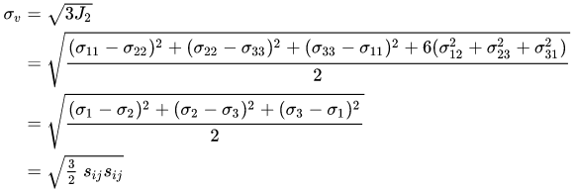

where **sij**represents the components of the stress deviator tensor **σ**dev



We will be using **sine** and **random vibrations** to conduct our vibration testing and analysis. The PCB is often the main resonant structure in the spacecraft electronic module and has natural resonant conditions differing from any mounted components and electronics housing. Sine vibration testing applies a single frequency and selectively excites resonant structures within the device. In a swept sine test, a vibration sine tone is ramped up and down through a range of frequencies and for a specified rate and duration. In contrast, random vibration tests apply vibration energy at all frequencies over a specified range. The frequency components that comprise the input signal are combined in phase and amplitude, resulting in a waveform that appears as random noise. This random waveform is allowed to change within the bounds of the programmed random input.

Results outputted by these tests can then be used to assess the stresses along the PCB, and thereby calculate margins of safety (MOS) for the PCB. By industry standard, the MOS is used to either accept or reject a component model design.

**Factors of safety** represent the reliability with respect to the flight limit loads, and are used to express how much stronger a system is than needed to bear the loads it is expected to encounter. Various load types are accounted for including design limit loads, yield loads and ultimate loads. The diagram below depicts the relationship between loads and the corresponding factors of safety (labelled with arrows):

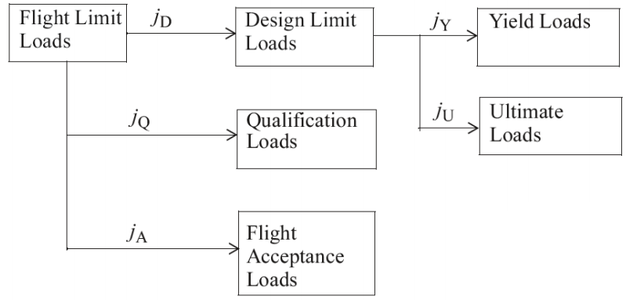

The probability of failure for any given factor is understood using its **margin of safety**, which can be calculated using the following formula:

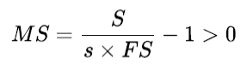

Here, S represents the design material strength (ultimate or yield), *s* is the predicted max load which will be applied and FS is a factor of safety. A good design always has **MS > 0**, as a value of 0 represents insufficiency in the structure when it comes to taking loads higher than expected. A negative value means the structure will fail before it even reaches the expected load. For an optimal balance between safety and design efficiency, an MS between 0 and 0.5 is sought after.

# **2. Pre-Lab**

Most vibration analysis starts with development of a response model to simulate the effects of the controlled vibrations on the nodal stresses, displacement and acceleration of the PCB. An industry recognized way is to utilize finite element analysis or FE analysis of a PCB. This has been done using the Siemens NX Response Simulation solver. Firstly, the PCB shown in Figure 5 was modelled in NX. A finite element model was developed from this part. In the FEM, the part was meshed with CTETRA meshing with an element size of 5 mm as seen in Figure 1. The 3D mesh was assigned to a mesh collector with PSOLID solid property, with material properties of the original PCB described in Table 2.

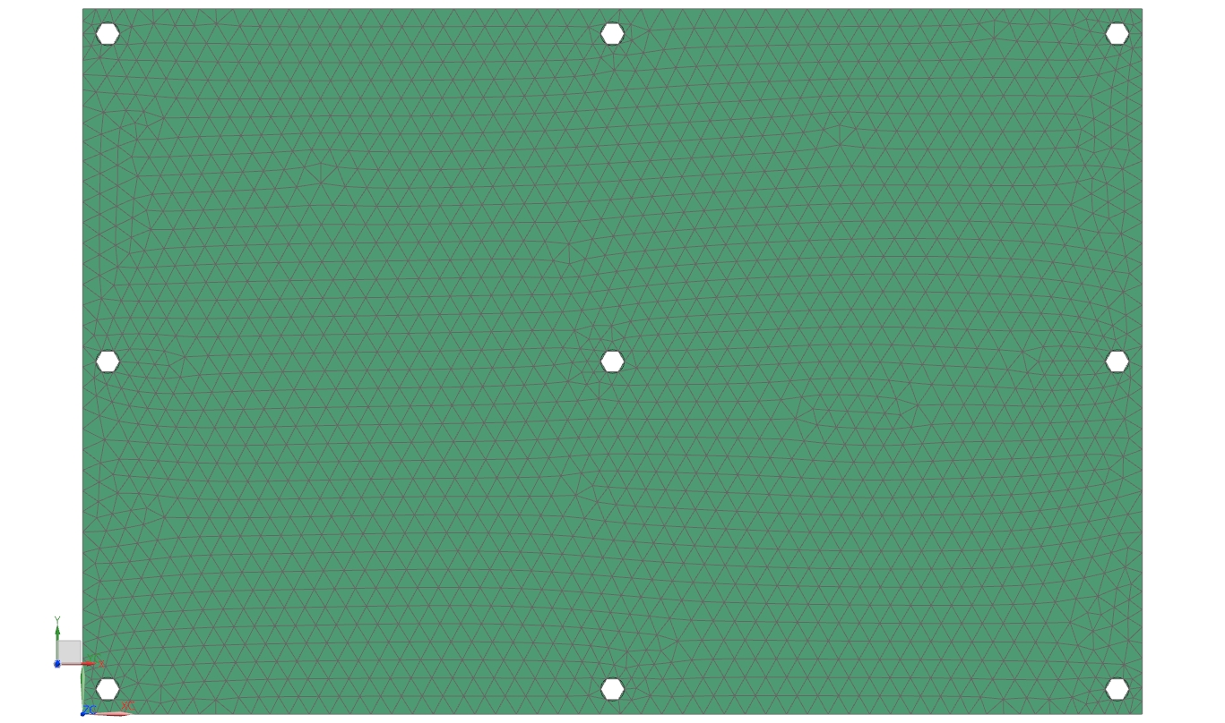

Figure 1. The meshed model of the PCB

A simulation was created using the FEM that used the NX Nastran solver for structural analysis to solve for a frequency response. Within the sim file, the mounting holes assigned to our group (1,2,5,8,9) were used to develop the user and the enforced motion constraints. The user constraint was used to only allow motion in the third degree of freedom (i.e. the along the z-axis). The enforced motion constraint was used to define the z-axis (DOF 3) as the axis for the enforced motion. The dynamics subcase card was defined using customised output requests and Lancos data. The output request enabled acceleration, displacement, spc forces, and stress requests for results. The Lancos method was defined with 0 Hz to 2200 Hz frequency range with 15 desired modes. This was done to encompass the testing parameters. Upon running the analysis and creating a response simulation, normal modes in Table 1 were found. A 5.0 viscous damping factor was also added to make the solution finite.

|  |  |  |
| --- | --- | --- |
| **Mode No.** | **Frequency** | **%Z_Mass** |
| Mode 1 | 2.3005e+002 Hz | 5.70043 |
| Mode 2 | 2.4192e+002 Hz | 37.51691 |
| Mode 3 | 6.2078e+002 Hz | 5.54946 |
| Mode 4 | 6.5971e+002 Hz | 14.99516 |
| Mode 5 | 8.6666e+002 Hz | 0.02068 |
| Mode 6 | 9.2536e+002 Hz | 15.29304 |
| Mode 7 | 1.0622e+003 Hz | 2.44432 |
| Mode 8 | 1.1096e+003 Hz | 0.18544 |
| Mode 9 | 1.6001e+003 Hz | 0.0069 |
| Mode 10 | 1.6369e+003 Hz | 0.00110 |
| Mode 11 | 1.7299e+003 Hz | 0.03067 |
| Mode 12 | 1.8467e+003 Hz | 0.00678 |
| Mode 13 | 2.0508e+003 Hz | 0.20288 |

Table 1. The normal modes of the PCB board computed by NX.

The %Z mass shows what percent of total PCB mass gets displaced along the z-axis. The highest %Z mass has been observed in mode 2. Of these modes, mode 1, 5 and 13 were found to have frequency values similar to those applied during the forced vibration sine test. Below are the displacement contour plots for these modes, which were then used to determine the accelerometer location.

|  |
| --- |
| a)  b)  c) |
| Figure 2. The contour plots of a) mode 1; b) mode 5; c) mode 13 |

Based on the contour plots shown in Figure 2, it is quite evident that on average, most movement during the sine test will be on the top right corner of the PCB. To check if it provides higher acceleration, it was compared with another arbitrary point on the board. Under the response simulation the new event was described as frequency type and mode acceleration as the data component. Within a new event, a translational nodal excitation is defined as enforced motion type and using the enforced motion constraint as the location. The excitation function was manually defined because NX was unable to access the Java Virtual library. The excitation function was in the z-axis and was defined with frequency values of low-level sine test. After solving the event for the excitation, a nodal function response was created acceleration as the result and a response node was selected in the top right part of the PCB, and the z-axis was the data component. For reference, we also plotted acceleration for an arbitrary point on the board. Figures 3 and 4 show the acceleration plots for the accelerometer location and the arbitrary point, respectively.

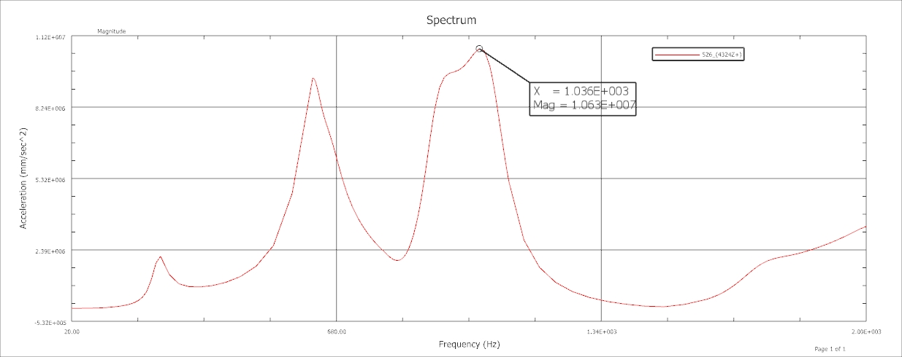

Figure 3. Acceleration plot of the accelerometer location (top right corner)

It is determined from Figure 3 that the top right corner of the PCB, where the accelerometer would be positioned, has an average acceleration of -5.78E+05 mm/s2 and a maximum acceleration of 1.063E+7 mm/s.

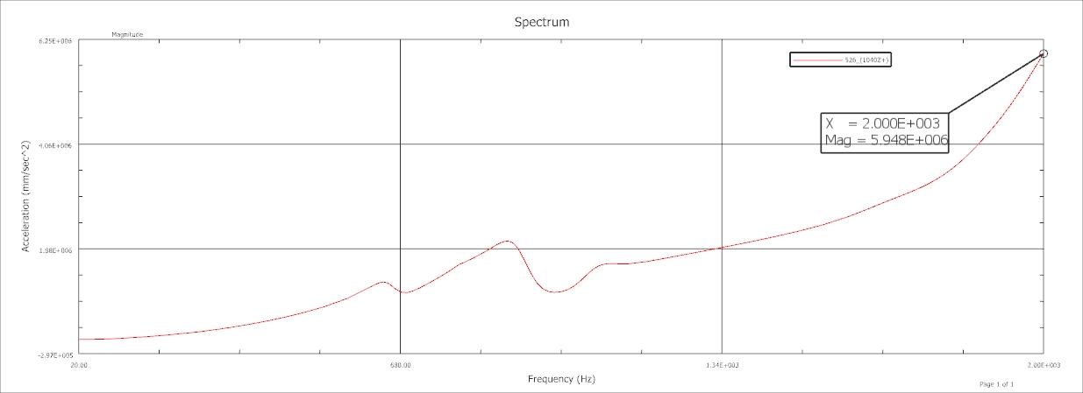

Figure 4. Acceleration plot of an arbitrary point (centre of the board)

The randomly chosen nodal point has an average acceleration 2.95E+5 mm/s2 and peak acceleration of 5.948E+6 mm/s2. When comparing the maximum acceleration of the two points, the point in the top right corner has the greater acceleration, which is why it is the optimal placement for the accelerometer during the physical vibration test.

After this a forced vibration analysis was done to find the peak stresses and contour plot. This is discussed in detail in the results.

**3. Methods**

## ***3.1 Board Properties***

The Printed Circuit Board (PCB) under analysis is a 370HR laminate and prepreg manufactured board which uses a high performance FR-4 multi-functional epoxy resin system. Applications of this board include superior thermal performance due to a low CTE as well as high CAF resistance preventing board processing failures. The current model exhibits the following attributes:

|  |  |
| --- | --- |
| **Material Property** | **Value** |
| Glass Transition Temperature (Tg) | 180 °C |
| Decomposition Temperature (Td) | 340 °C |
| Dielectric Constant | 4.04 |
| Dissipation Factor | 0.021 |
| Density (RHO) | 0.0426 lb/in3 |
| Tensile Strength | Length direction: **55.9 ksi**  Cross direction: **35.6 ksi** |
| Young’s Modulus (Y) | Length direction: **3744 ksi**  Cross direction:  **3178 ksi** |
| Poisson’s Ratio (v) | Length direction: **0.177**  Cross direction: **0.171** |

Table 2. PCB Material Properties (2)54e

The product number for the particular PCB used for this analysis is **IPC-4101** - / 98 / 99 / 101 126 which has the following specifications:

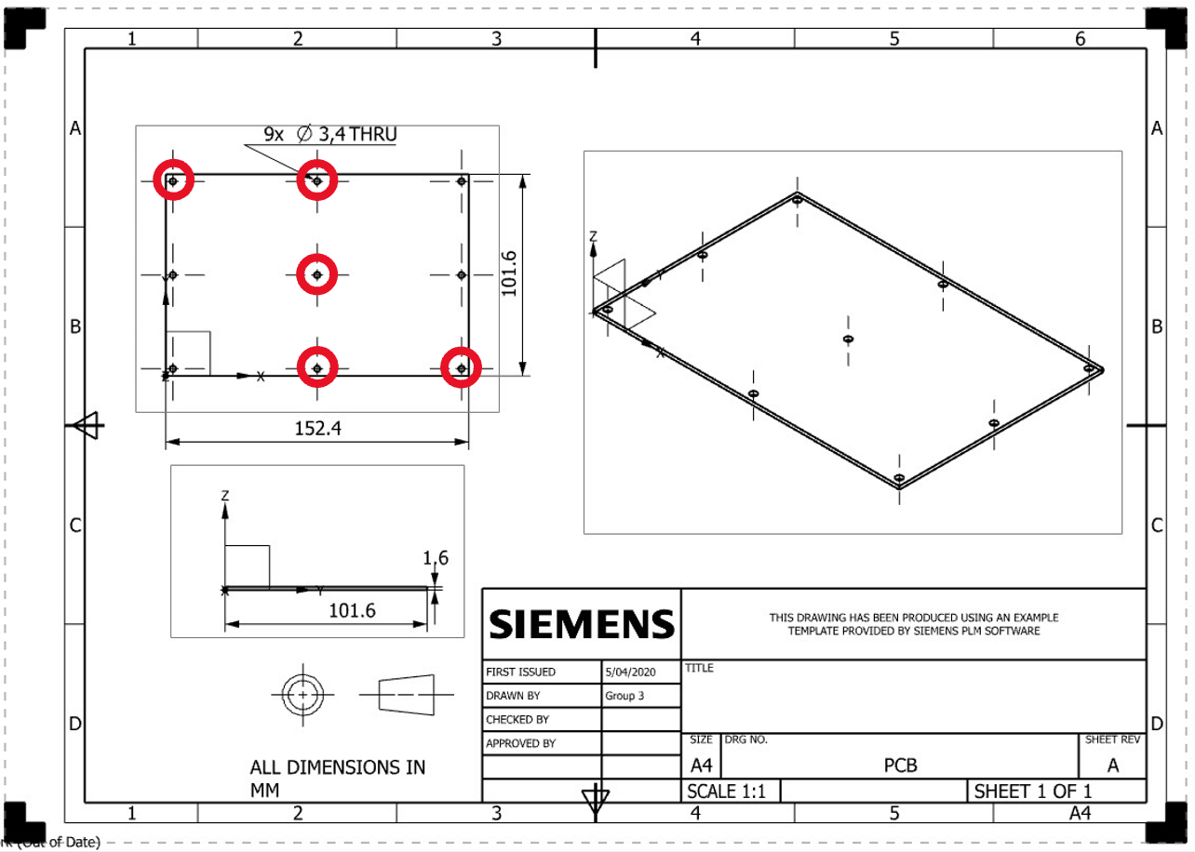

|  |
| --- |
| **Dimensions (mm)** |
| Length = 152.4 |
| Width = 101.6 |
| Thickness = 1.6 |

Figure 5. A technical drawing of the PCB

As indicated in Figure 5, there are 9 fasteners located across the PCB which will be used to mount the PCB during testing. Depending on the location of the PCB constraints the natural modes may vary, which would result in variations in displacement across the board. The fastener locations assigned to Group C are 1, 4, 6, 3, 6 & 9, however because we were unable to perform the testing, the locations for Group D were used instead. These locations are 1, 2, 5 , 8 & 9, and can be found in Figure 5.

## ***3.2 Experimental Set-Up***

The printed circuit board was mounted on the vibration table as shown in Figure 6, it was fastened to the fixture using bolts #1, 2, 5, 8, and 9, highlighted in Figure 5. Then, the accelerometer was placed on the top right corner of the board as shown in Figure 7. This specific placement of the accelerometer, determined in the Pre-Lab NX Analysis, was chosen as this location had the largest acceleration value, meaning the most displacement occurred at this point on the board. This is important as the accelerometer will be able to detect the motion of the board more efficiently.

Then the board would undergo the following sequence of tests:

1. Low level sine test: low frequency vibrations under 100 Hz
2. Sine: medium frequency vibrations stepped from 20 Hz - 2000 Hz
3. Low level sine test
4. Random test: random loads of vibration
5. Low level sine test

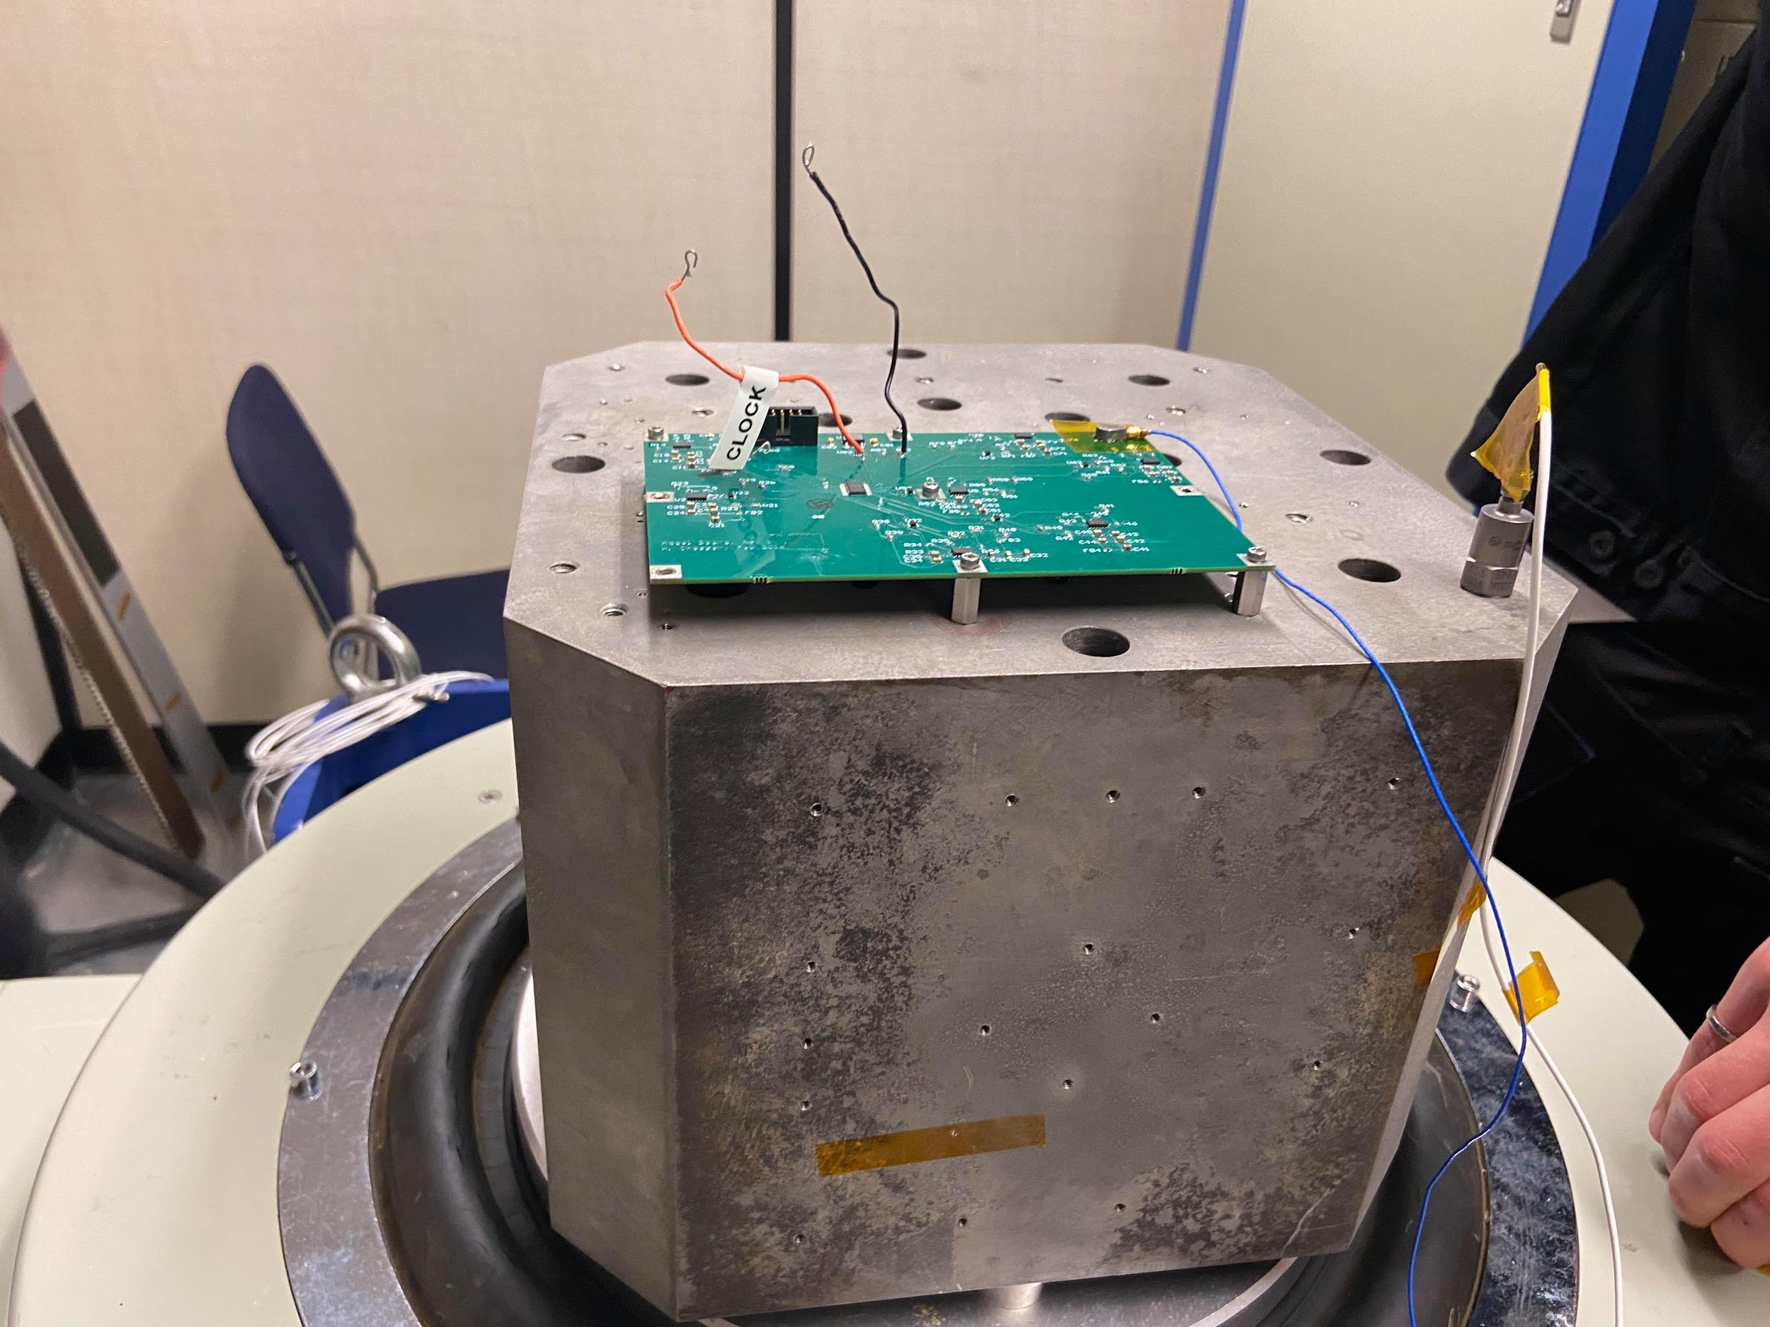

Figure 6. The PCB fastened to the vibration table

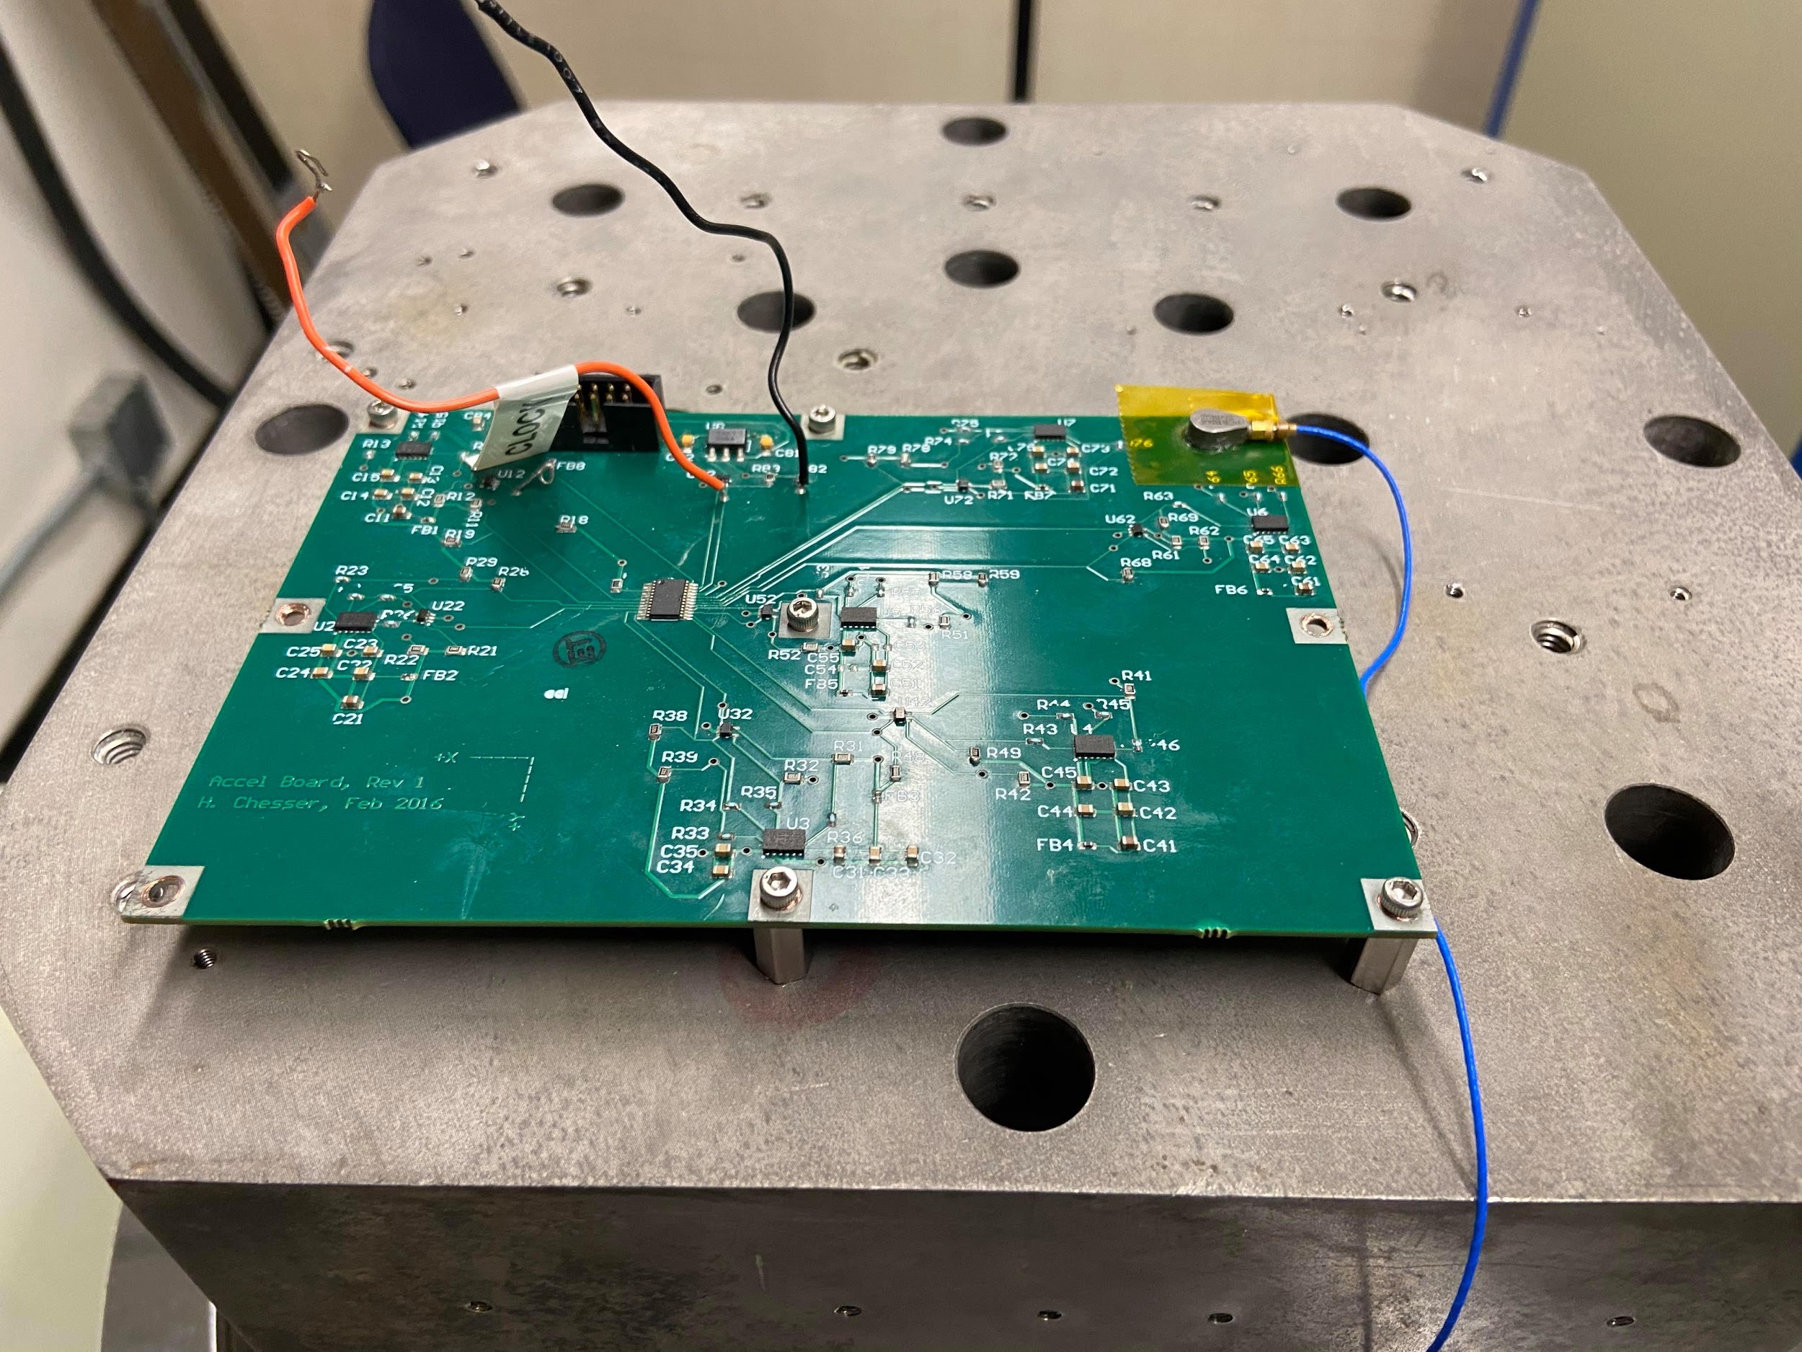

Figure 7. The accelerometer (connected to the blue wire) mounted on the top right corner of the PCB.

# **4. Results and Discussion**

Five vibration analysis tests were applied to the PCB to verify component performance. The order in which the tests were applied to the mounted PCB was: low-sine, sine, low sine, random and low sine. These tests yielded the following vibration plots:

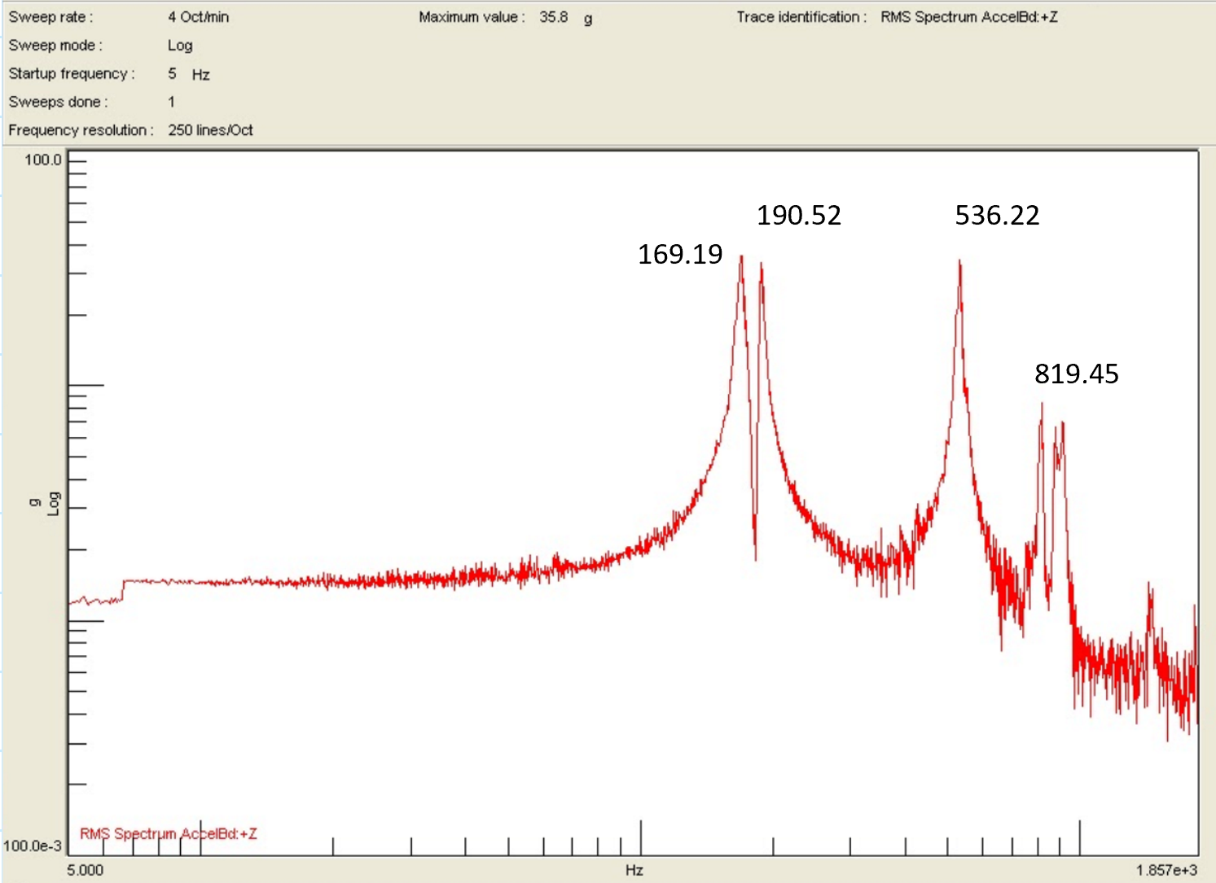

Figure 8. Low-Level Sine Wave Analysis Test 1

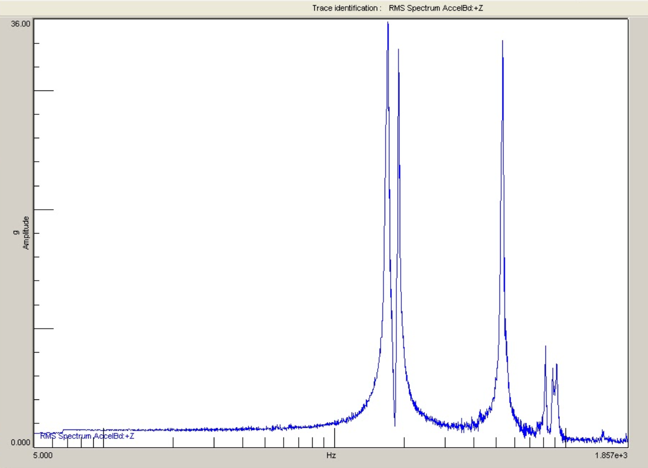

Figure 9. Sine Wave Analysis Test 2

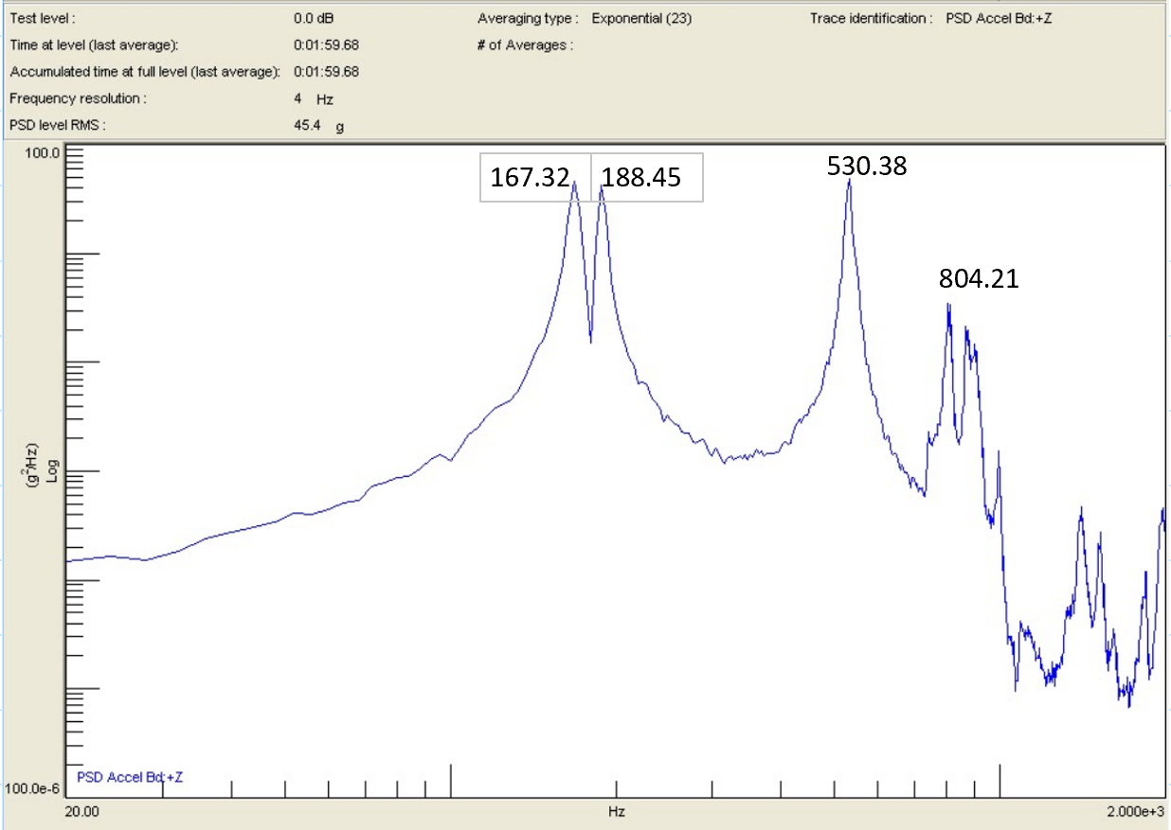

Figure 10. Random Wave Analysis Test 4

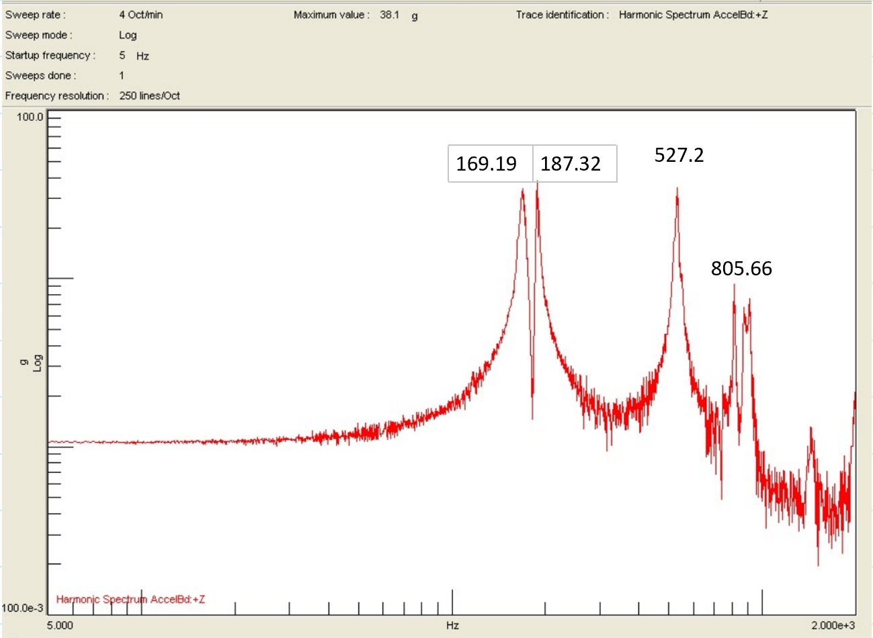

Figure 11. Low Level Sine Wave Analysis Test 5

The above test analysis outputs represent the frequency of vibration versus the amplitude excitation applied to the PCB. The peaks seen in Figures 8-11 represent the natural frequency of the board as a response to the excitation in the z-axis. These natural frequencies are measured as follows:

|  |  |
| --- | --- |
| **Test** | **Natural Frequencies Measured (Hz)** |
| Low Level Sine Analysis 1 | 169.19  190.52  536.22  819.45 |
| Low Level Sine Analysis 2 | NA |
| Low Level Sine Analysis 5 | 169.19  187.32  527.2  805.66 |

Table 3. Low Level Sine Analysis Frequency Measurements

Comparing the measured natural frequencies against the simulated values, the percent difference can be calculated. This percent difference is important in validating the accuracy of the tests results and possible margins of error. To determine this value, the measured natural frequencies were averaged based on the first and fifth vibration test. The third test (low sine wave analysis) was not included as the values were not available.

|  |  |  |
| --- | --- | --- |
| **Measured Natural Frequency (Hz)** | **Simulated Natural Frequency- *Averaged***  **(Hz)** | **% Difference** |
| 169.19 | - |  |
| 188.92 | 251.9 | 28.6 |
| 531.71 | 620.8 | 15.5 |
| 812.55 | 1036 | 24.2 |

Table 4. Comparison of Simulated and Measured Natural Frequencies of PCB

Referring to Table 4, it can be seen that the natural frequencies of the PCB had a percent difference of 28.6%, 24.2% and 15.5%. These values of percent difference are relatively high and are not ideal for comparison purposes. There are several reasons to attribute the large difference in measurements. First, the results for the third experiment were not included in analysis, which decreases the accuracy of the measured frequencies. Second, human error can attribute to inaccurate simulated values as well as measured values. Lastly, technical errors in NX software can result in skewed data.

The natural frequencies measured in the PCB represent the oscillation wave displacement of the board at specified frequencies. This displacement varies for each mode of natural frequency and contributes to stress moving through the board. This stress value is determined by measuring the acceleration of the PCB during frequency response analysis via accelerometer.

Once the accelerometer location was decided, a forced vibration analysis was simulated to determine the stresses within the PCB. This was done by simulating a functional nodal response with result type as stress and the data component as Von Mises. For the purposes of generalizing, we selected all nine mounting holes on the PCB. Outputted stress responses are represented below with the corresponding frequency.

To calculate the MOS, the below equation was used with varying stress values. The variable AS is the allowable stress of the material, in our case it is the ultimate tensile strength. DS is the design stress, or the maximum expected stress. The Von Mises Stress experienced by each hole is used for DS in the calculations. Referring to the NASA Structural Design and Test Factors Manual (1), the Factor of Safety (FS) of 1.4 is used to calculate reliably:

## ***5.1 Calculation of Margin of Safety for the entire PCB***

AS = 35.6 ksi = 2.4545E+8 Pa

DS = 20.43 MPa = 20.43E+6 Pa

FS = 1.4

$MS= \frac{AS}{DS×FS}-1$

$MS= \frac{2.4545E+8 Pa}{(1086.11E+6 Pa)×1.4}-1=-0.839$

The same process was implemented to calculate MOS values in Table 5.

|  |  |  |  |
| --- | --- | --- | --- |
| **Hole no.** | **Von Mises Stress (MPa)** | **Frequency (Hz)** | **Margin of Safety** |
| Hole 1 | 578 | 9.14E+02 | -0.697 |
| Hole 2 | 477 | 6.60E+02 | -0.632 |
| Hole 3 | 36.2 | 6.21E+22 | 3.843 |
| Hole 4 | 130 | 9.25E+02 | 0.349 |
| Hole 5 | 480 | 9.25E+02 | -0.635 |
| Hole 6 | 279 | 6.24E+02 | -0.372 |
| Hole 7 | 61.3 | 1.361+02 | 1.86 |
| Hole 8 | 639 | 1.07E+03 | -0.726 |
| Hole 9 | 638 | 9.14E+02 | -0.725 |

Table 5. The Von Mises stresses of all the holes

Analyzing Table 5, it is seen that the selected mounting holes (1,2,5,8,9) have a greater Von Mises stress magnitude compared to the other mounting holes. This is confirmed in the contour plot for the Von Mises stresses.

The Von Mises stress contour plot was outputted by first creating a random type event with the same response function, selecting evaluated RMS contour results and selecting stress as the result with Von Mises as the response request. To reduce processing time significantly only small areas surrounding the mounting holes have been selected for analysis. The resulting plot is shown in Figure 12, with largest stress acting on the constrained screw locations. This is compared to the maximum allowable stress of the PCB material to derive the MOS. The MOS was calculated at each screw point and it was seen at the constrained locations the MOS < 0, meaning the design of the PCB setup could be improved. The computed MOS seemed a little off because most of them are negative, meaning that the board experiences structural failure. This error might be due to some assumptions made during the NX simulation process, or it might be a human error that could have occured in any step of the analysis.

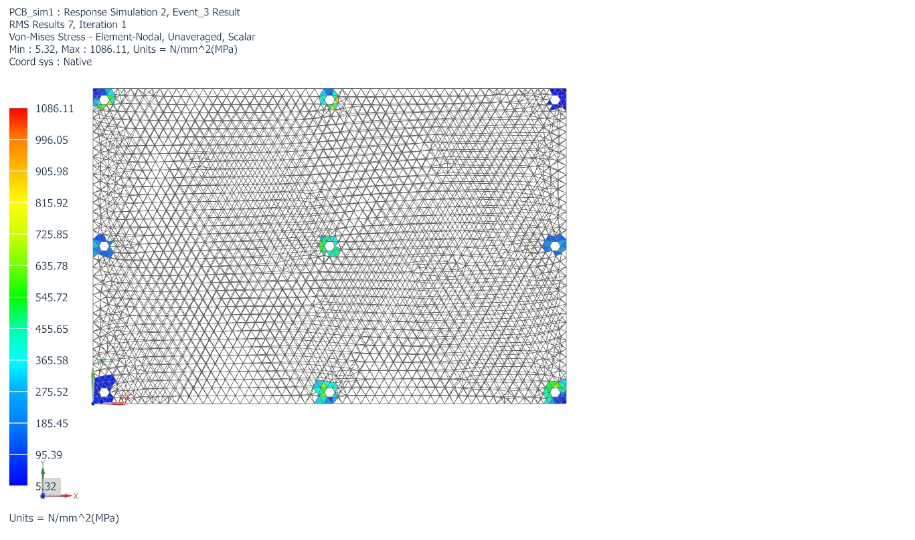

Figure 12. The contour plot of the Von-Mises stresses

# **6. Conclusion**

The analysis has given some interesting results. The acceleration values modeled were off by a significant margin, showing that the model can be updated to more accurately predict these values. Additionally, using the stress values simulated, it was predicted that the PCB will not be able pass the stress test because the evaluated Margins of Safety are negative. The model could be further improved by 1) creating a more detailed functional response; 2) using less idealized models; 3) gaining more knowledge and practice in using NX.

Frequency response analysis is an important step in determining the reliability of a spacecraft component. During launch, vehicle components experience frequency loads which lead to displacement and increased stress. Using simulation software along-side experimental testing, component functionality and performance can be analysed to either confirm or reject model designs.

# **7. References**

1. Daniel R. Mulville. (1996). STRUCTURAL DESIGN AND TEST FACTORS OF SAFETY FOR SPACEFLIGHT HARDWARE. 10-14. National Aeronautic and Space Administration. <https://standards.nasa.gov/sites/default/files/nasa-std-5001.pdf?fbclid=IwAR1jOSZ9Z01ZrcxLNAbc58A4EBbJwIqLur9OhZfyzXHawnuEDTmOBMqhWik>

2. “370HR.” *Isola Group*, 7 Feb. 2020, [www.isola-group.com/products/all-printed-circuit-materials/370hr/](http://www.isola-group.com/products/all-printed-circuit-materials/370hr/).